Manual Therapy, Posturology & Rehabilitation Journal
Formely REVISTA TERAPIA MANUAL

https://doi.org/10.17784/mtprehabjournal.2022.20.1254

International Severe Acute Respiratory and Emerging Infection Consortium (ISARIC). A new collaborative global platform for global clinical trials targeting post-COVID-19 patients
Maria Izabel C. Siqueira¹*, Miriã C. Oliveira¹, Maria Eduarda M. Lino², Shayra Kellen A. Souza², Guilherme Augusto M. Silva¹, Renata S. R. Tomaz³, Marilúcia M. Carrijo¹, Thays L. Guedes², Beatriz N. Souza², Elisângela R. P. Póvoa², Rubens R. Bernardes², Letícia S. Galvão², Bianca M. Reis², Raphael H. C. O. Diniz², Diogo M. Paulino², Aline C. Oliveira², Rodolfo P. Vieira¹, Vinicius Z. M. Silva¹, Sara S. Faria¹, Luís V. F. Oliveira^{1*}, Deise A. A. P. Oliveira¹.
¹Human Movement and Rehabilitation Post Graduation Program, Evangelical University of Goiás (UniEVANGELICA), Anápolis (GO), Brazil; ²Scientific Initiation Program, Evangelical University of Goiás, (UniEVANGELICA), Anápolis (GO), Brazil; ³Faculty of Psychology, Evangelical University of Goiás (UniEVANGELICA), Anápolis (GO).
ABSTRACT
Background: In response to the pandemic caused by COVID-19, World Health Organization (WHO), together with International Severe Acute Respiratory and Emerging Infection Consortium (ISARIC), developed research protocols facilitating global collaboration and accelerating the understanding of the disease, to identify the potential symptoms and persistent sequelae in infected individuals, which can be used in different areas of health, that is, in primary care, at a hospital or outpatient level, both public and private. Objective: To describe the International Severe Acute Respiratory and Emerging Infection Consortium (ISARIC) protocol as a new global collaborative platform for global clinical trials targeting post-COVID-19 patients. Methods: The standardized forms were developed from the COVID-19 Clinical Characterization Protocol (PCC) by the ISARIC/WHO working group composed of specialist researchers with experience in clinical research in different areas of medicine and public health, especially outbreaks and infectious diseases. Conclusion: It is expected that the creation of a database composed of different populations from all over the world will help in the characterization of risk factors, in the best form of clinical intervention and in the best prevention strategies for physical, neurological and psychosocial sequelae in the medium and long term in post-COVID-19 patients.
Keywords: ISARIC; SARS-CoV-2; COVID-19; Clinical trials.

BACKGROUND
In December 2019, a new coronavirus (COVID- 19) appeared in Hubei Province, Wuhan City, China, which mainly affects the respiratory system of humans at different levels of severity. However, according to the immune response of each patient, the cardiovascular, renal, neurological, and musculoskeletal systems may also be compromised, as well as dysfunctions in blood clotting⁽¹⁻⁴⁾. In the acute phase of the disease, mild cases usually present with fever, cough, and muscle fatigue. In contrast, moderate to severe cases cause dyspnea, which can progress to acute respiratory distress syndrome (ARDS), leaving severe sequelae in the lungs of survivors or leading to death^{(5,6)}.
With the increase in the number of cases and deaths in several countries around the world, this disease was declared a pandemic on March 11, 2020, by the World Health Organization (WHO)⁽⁷⁾. People with advanced age, unvaccinated against COVID-19,

hypertensive, immunosuppressed, and with chronic lung or heart diseases before COVID-19 are at greater risk of developing the severe condition and having a poor prognosis, requiring intensive care⁽⁸⁻¹⁰⁾.
Despite the rapid development, production of vaccines, and effective treatments, COVID-19 continues to generate serious and widespread repercussions for health^{(8,11,12)}. In cases considered to be symptomatic, the manifestations usually appear on the fifth day of infection, with a higher rate of hospitalization on the seventh day and worsening of the infection, evolving to ARDS on the eighth day⁽¹³⁾. After the period of transmission or hospital discharge, the main reports are dyspnea and muscle fatigue, however, a multitude of complaints have been described in the scientific literature, such as reduced lung function, generalized myalgia, arthralgia, muscle weakness, psychosomatic symptoms, and impairment of health-related quality of life(14-17).

SHORT COMMUNICATION

*Corresponding author: Luis V F Oliveira: e-mail: oliveira.lvf@gmail.com

Submission date 24 May 2022; Acceptance date 20 October 2022; Publication date 01 November 2022
Manual Therapy, Posturology & Rehabilitation Journal. ISSN 2236-5435. Copyright © 2020. This is an Open Access article distributed under the terms of the Creative Commons Attribution Non-Commercial License which permits unrestricted non- commercial use, distribution, and reproduction in any medium provided article is properly cited
1

Thus, given the diversity of persistent clinical and functional changes in patients affected by severe acute respiratory syndrome coronavirus 2 (SARS-CoV- 2), it is necessary to characterize the risk predictors and highlight the frequency, severity, and interaction of these complications using standardized tools that make it possible to track these manifestations in the short, medium, and long term, considering that many already have previously vulnerable health conditions⁽¹⁸⁾.
For the establishment of protocols and clinical decision-making, robust and concrete data are needed that can guide and support the actions, therefore, the elaboration of a standardized clinical database composed of many patients from several countries, with multiple ethnicities, cultures, and socioeconomic levels increases the accuracy to respond to the global impact of COVID-19.
In this way, scientific evidence from studies with a smaller population specific to each country makes it possible to compare clinical data, providing subsidies that help in the development of health policies and future global health research⁽¹⁹⁾. The purpose of this study is to describe the International Severe Acute Respiratory and Emerging Infection Consortium (ISARIC) protocol as a new global collaborative platform for global clinical trials targeting post-COVID-19 patients.

International Severe Acute Respiratory and Emerging Infection Consortium (ISARIC)/OMS COVID-19
In response to the pandemic caused by COVID- 19, WHO, together with ISARIC, developed research protocols facilitating global collaboration and accelerating the understanding of the disease, to identify the potential symptoms and persistent sequelae in infected individuals, which can be used in different areas of health, that is, in primary care, at a hospital or outpatient level, both public and private⁽¹⁸⁻
22).
ISARIC is a global federation focused on providing proficient, coordinated, and rapid research responses to outbreak-prone infectious diseases as a means of preventing the incidence of cases and deaths⁽²³⁾. With the emergence of COVID-19, a group called the Coronavirus Clinical Characterization Consortium (ISARIC4C) was created, which is funded by two important research projects in the United Kingdom⁽²⁴⁾.
The United Kingdom Research and Innovation (UKRI) and the National Institute for Health Research (NIHR) proposed sharing data collected in several countries and thus obtaining agile responses that collaborate for the establishment of management
protocols for patients affected by COVID-19. The data and tools generated by ISARIC are available and can be accessed free of charge by any investigator and provide a parameter for other studies, such as clinical trials of new therapies. The database generated is intended to accelerate the understanding of the pathophysiology and outcomes of COVID-19 through the exchange of detailed clinical information on patients who were infected and had different outcomes. The population and geographic diversity and the different levels of resources from which the data originate increase the possibility of comparing and generalizing the evidence^{(25,26)}.
When grouping, standardizing, and sharing a large amount of distinct data, management efforts composed of specialized teams are focused on ensuring that researchers access data efficiently and perform analysis, aimed at solving the relevant problems of the patients in their different aspects. In this way, access to these data stimulates research and scientific integrity, increasing transparency and playing an essential role in the production of new knowledge, which consequently improves the management of these patients, impacting public health policies and bringing significant social benefits to patients. several countries involved⁽²⁷⁾.
According to the latest available report, the ISARIC COVID-19 Clinical Database consisted of the registry of 708,158 patients infected and hospitalized with SARS-CoV-2 in 62 countries, collected by various clinical teams at 1,559 participating institutions from January to September 2021. Of the data entered in September 2021, 552,366 (78%) patients had laboratory-confirmed SARS-CoV-2 infection and 50,426 (7.1%) were clinically diagnosed. The mean age of these patients was 58 years (IQR: 44-72) years, 48.9% were males and 50.9% were females, with a total of 126,069 (20.9%) patients requiring intensive care with 23.5% of hospital mortality⁽¹¹⁾.
The main comorbidities reported were systolic arterial hypertension (30.7%), type 2 diabetes mellitus (29.6%), and chronic heart failure (10.5%). Regarding the main symptoms at admission, cough (23.7%), dyspnea (19.8%), fever (17.5%), and fatigue (11.5%) were reported. The most identified complications were viral pneumonia (16.2%), ARDS (6.6%), acute kidney injury (5.5%), anemia (4.3%), and bacterial pneumonia (3.8%)⁽¹¹⁾.

ISARIC/WHO COVID-19 long-term follow-up protocols and studies
The standardized forms were developed from the COVID-19 Clinical Characterization Protocol (PCC) by the ISARIC/WHO working group composed of specialist

researchers with experience in clinical research in different areas of medicine and public health, especially outbreaks and infectious diseases. Core or Rapid case report forms (CRFs) protocols were also used, which specifically collect sociodemographic data, pre-existing comorbidities, signs, and symptoms present in the acute phase of the infection, and types of therapies administered during hospitalization⁽²⁸⁾.
All these data from the acute clinical condition were grouped with the other follow-up data, complementing the forms, which thus make it possible to measure the risk factors for long-term sequelae in physical and psychosocial health in people after the positive diagnosis for COVID-19 was confirmed through laboratory tests. Data collection can be performed through a survey conducted by professionals via teleservice or in person and through self-assessment via an online link or mail⁽¹⁸⁾.
These tools can be used for the assessment and follow-up of patients in healthcare settings or partnership with scientific sampling and diagnostic studies, being available in multiple languages and offering global accessibility. The protocol consists of three data collection forms that can be completed at different times after COVID-19 infection: 1) Tier 1 Initial Freestanding follow-up survey (can be applied by anyone in the first assessment, whether hospitalized or not); 2) Tier 1 Initial Follow up survey (used for a person with a Core or Rapid CRF performed during an acute hospital stay as a first assessment); 3) Tier 1 Ongoing survey (used for subsequent assessments with flexible and adaptable time intervals) (Figure 1). Clinical follow- up is recommended to continue beyond 12 months, at 3- to 6-month intervals for up to 3 years, depending on available resources^{(18,29)}.

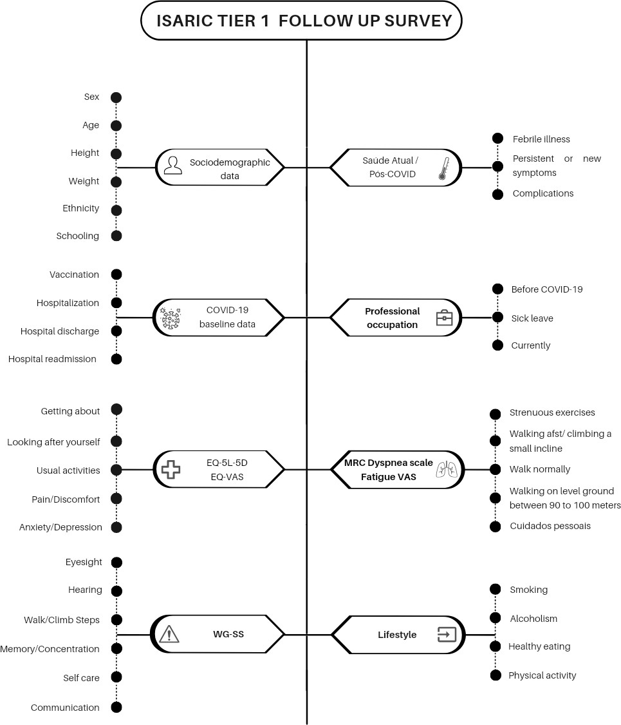

Figure 1. ISARIC tier 1 follow up survey.
*Note: ISARIC- International Severe Acute Respiratory and Emerging Infection Consortium; EQ-5L-5D – EuroQol 5 levels 5 dimensions; EQ- VAS – EuroQol Visual Analogue Scale; WG-SS – Washington group short set.

This open database is composed of data on physical and psychosocial health, occupational status, and socioeconomic data, in addition to pre-COVID-19 baseline data that make it possible to characterize the physical and psychosocial repercussions after hospital discharge and/or acute phase. Among them, we highlight data on vaccination, hospitalization and possible readmissions, specific consequences, including deep vein thrombosis (DVT), stroke or transient ischemic attack, pulmonary embolism, recent febrile illness, new or persistent clinical symptoms^{(18,29)}.
In the ISARIC protocol, quality of life is assessed by the EuroQol five dimension five levels (EQ-5D-5L). This instrument was introduced by the EuroQol Group in 2009 to improve reliability and sensitivity when compared to the EQ-5D-3L. The EQ-5D-5L essentially consists of the EQ-5D descriptive system, composed of five dimensions: mobility, self-care, usual activities, pain/discomfort, and anxiety/depression. Each dimension has 5 levels of severity: no problems, mild problems, moderate problems, severe problems, and extreme problems. According to the instrument, the patient is asked to indicate their health status in each of the five dimensions^{(30,31)}. From the scores generated by each domain, a score can be calculated with higher scores representing a better quality of life⁽³²⁾.
The EuroQol Visual Analogue Scale (EQ VAS) records the patient's self-perception of health on the day of the interview on a vertical visual analog scale scored from 0 to 100, where the endpoints are labeled "The best health you can imagine" and " The worst health you can imagine." The VAS is used as a quantitative measure of the health condition that reflects the judgment of the patient⁽³³⁾.
In the ISARIC protocol, dyspnea is measured by the Medical Research Council (MRC) dyspnea scale. This instrument assesses the sensation of dyspnea during activities of daily living (ADLs), being traditionally used in the international literature mainly because it is easy to apply and understand. The original version in English is validated, as well as the version in Portuguese⁽³⁴⁾. The MRC scale is composed of five items, and the patient chooses the item that corresponds to how much dyspnea limits their ADLs. The patient reports his subjective degree of dyspnea by choosing a value between 1 (suffers from shortness of breath only during intense exercise) to 5 (feels short of breath when getting dressed or feels so short of breath that he never leaves the house)⁽³⁵⁾.
Difficulties in ADL's due to health problems are evaluated by the Washington Group Short Set on Functioning (WG-SS) which is composed of a summarized set of questions about the patient's
functionality, seeking to identify people who have disabilities based on the lowest possible number of questions. Its questions reflect advances in the conceptualization of disability and use the World Health Organization (WHO) International Classification of Functioning, Disability and Health (ICF) as a conceptual framework⁽³⁶⁾.
The WG-SS consists of six questions, whose objective is to verify the degree of difficulty faced by a person to carry out activities in six basic domains of functionality, that is, to judge whether people with disabilities are participating in all aspects of life in society in equal conditions. The questions cover vision, hearing, mobility, cognition (memory/concentration), self-care, and communication. Each question has four categories of answers, which were read after each question was asked, ranging from “no, no difficulty” to “I can't do it at all”⁽³⁷⁾.
Finally, the ISARIC protocol evaluates the lifestyle encompassing four habits, namely smoking, alcohol consumption, healthy eating, and physical activity, where it is verified if the patient does it more or less frequently, if there was no difference or if had no such practice before COVID-19.

CONCLUSION
Given the above, it can be observed that the research forms presented, as well as the creation of a database composed of different populations from around the world, help in the characterization of risk factors, the best way of clinical intervention, and prevention strategies for long-term physical and psychosocial consequences in post-COVID-19 patients. ISARIC also provides data for clinical intervention, physical and neurological rehabilitation, and mainly for public health management, with a focus on reducing global morbidity and mortality from COVID-19. This important database also helps by providing subsidies for the development of clinical research that can be implemented in environments with different resources for health care.

Authors' contribution: MICS, MCO, MEML, SKAS, GAMS, RSRT, MMC, TLG, BNS, ERPP, RRB, LSG, BMR, ERPP, RHCOD, DMP, ACO,
RPV, VZMS, SSF, LVFO contributed to the project design, data collection and interpretation. MICS, MCO, MEML, SKAS, SSF, LVFO contributed to the elaboration, critical review, correction and approval of the final version.

Financial support: Nothing to declare

Conflict of interest: the authors declare that they have no conflict of interest

REFERENCES
- Lin L, Lu L, Cao W, Li T. Hypothesis for potential pathogenesis of SARS-CoV-2 infection-a review of immune changes in patients with viral pneumonia. Emerg Microbes Infect. 2020;9(1):727-32.
- Zaim S, Chong JH, Sankaranarayanan V, Harky A. COVID-19 and Multiorgan Response. Curr Probl Cardiol. 2020;45(8):100618.
- Louis TJ, Qasem A, Abdelli LS, Naser SA. Extra- Pulmonary Complications in SARS-CoV-2 Infection: A Comprehensive Multi Organ-System Review. Microorganisms. 2022;10(1):153. 10010153.
- Connors JM, Levy JH. COVID-19 and its implications for thrombosis and anticoagulation. Blood. 2020;135(23):2033-40.
- Robineau O, Wiernik E, Lemogne C, de Lamballerie X, Ninove L, Blanché H, et al. Persistent symptoms after the first wave of COVID-19 in relation to SARS-CoV-2 serology and experience of acute symptoms: A nested survey in a population-based cohort. Lancet Reg Health Eur. 2022;17:100363.
- Tamminen P, Kerimov D, Viskari H, Aittoniemi J, Syrjänen J, Lehtimäki L. Lung function during and after acute respiratory infection in COVID-19 positive and negative outpatients. Eur Respir J. 2022;59(3):2102837.
- Cucinotta D, Vanelli M. WHO Declares COVID-19 a Pandemic. Acta Biomed. 2020;91(1):157-60.
- Sezen YI, Senoglu S, Karabela SN, Yesilbag Z, Borcak D, Canbolat Unlu E, et al. Risk factors and the impact of vaccination on mortality in COVID- 19 patients. Bratisl Lek Listy. 2022;123(6):440-43.
- Alharbi AM, Rabbani SI, Halim Mohamed AA, Almushayti BK, Aldhwayan NI, Almohaimeed AT, et al. Analysis of potential risk factors associated with COVID-19 and hospitalization. Front Public Health. 2022;10:921953.
- ISARIC Clinical Characterisation Group. COVID-19 symptoms at hospital admission vary with age and sex: results from the ISARIC prospective multinational observational study. Infection. 2021;49(5):889-905.
- Reyes LF, Murthy S, Garcia-Gallo E, Irvine M, Merson L, Martin-Loeches I, et al. Clinical characteristics, risk factors and outcomes in patients with severe COVID-19 registered in the International Severe Acute Respiratory and Emerging Infection Consortium WHO clinical characterisation protocol: a prospective,
multinational, multicentre, observational study. ERJ Open Res. 2022;8(1):00552-2021.
- Reyes LF, Bastidas A, Narváez PO, Parra-Tanoux D, Fuentes YV, Serrano-Mayorga CC, et al. Clinical characteristics, systemic complications, and in- hospital outcomes for patients with COVID-19 in Latin America. LIVEN-Covid-19 study: A prospective, multicenter, multinational, cohort study. PLoS One. 2022;17(3):e0265529.
- WHO. Global surveillance for human infection with coronavirus disease (COVID2019) [Internet]. [cited 25 Aug 2020]. Available from: https://www.who.int/publications-detail/global- surveillance-forhuman- infection- withnovelcoronavirus-(2019-ncov)
- Alkodaymi MS, Omrani OA, Fawzy NA, Shaar BA, Almamlouk R, Riaz M, et al. Prevalence of post- acute COVID-19 syndrome symptoms at different follow-up periods: a systematic review and meta- analysis. Clin Microbiol Infect. 2022;28(5):657-66.
- de Oliveira Almeida K, Nogueira Alves IG, de Queiroz RS, de Castro MR, Gomes VA, Santos Fontoura FC, et al. A systematic review on physical function, activities of daily living and health-related quality of life in COVID-19 survivors. Chronic Illn. 2022:17423953221089309.
- Malik P, Patel K, Pinto C, Jaiswal R, Tirupathi R, Pillai S, et al. Post-acute COVID-19 syndrome (PCS) and health-related quality of life (HRQoL)-A systematic review and meta-analysis. J Med Virol. 2022;94(1):253-62.
- Badenoch JB, Rengasamy ER, Watson C, Jansen K, Chakraborty S, Sundaram RD, et al. Persistent neuropsychiatric symptoms after COVID-19: a systematic review and meta-analysis. Brain Commun. 2021;4(1):fcab297.
- Sigfrid L, Cevik M, Jesudason E, Lim WS, Rello J, Amuasi J. What is the recovery rate and risk of long-term consequences following a diagnosis of COVID-19? A harmonised, global longitudinal observational study protocol. BMJ open, 2021; 11(3), e043887.
- ISARIC Clinical Characterization Group, Garcia- Gallo E, Merson L, Kennon K, Kelly S, Citarella BW, et al. ISARIC-COVID-19 dataset: A Prospective, Standardized, Global Dataset of Patients Hospitalized with COVID-19. Sci Data. 2022;9(1):454.
- ISARIC Clinical Characterization Group. The value of open-source clinical science in pandemic

response: lessons from ISARIC. The Lancet. Infectious diseases. 2021;21:1623-24.
- Bloom CI, Drake TM, Docherty AB, Lipworth BJ, Johnston SL, Nguyen-Van-Tam JS, et al. Risk of adverse outcomes in patients with underlying respiratory conditions admitted to hospital with COVID-19: a national, multicentre prospective cohort study using the ISARIC WHO Clinical Characterisation Protocol UK. Lancet Respir Med. 2021;9(7):699-711.
- Docherty AB, Harrison EM, Green CA, Hardwick HE, Pius R, Norman L, et al. Features of 20 133 UK patients in hospital with covid-19 using the ISARIC WHO Clinical Characterisation Protocol: prospective observational cohort study. BMJ. 2020;369:m1985.
- ISARIC Clinical Characterisation Group. The value of open-source clinical science in pandemic response: lessons from ISARIC. Lancet Infect Dis. 2021;21(12):1623-24.
- Gupta RK, Harrison EM, Ho A, Docherty AB, Knight SR, van Smeden M, et al. Development and validation of the ISARIC 4C Deterioration model for adults hospitalised with COVID-19: a prospective cohort study. Lancet Respir Med. 2021;9(4):349-59.
- Vuong QH. The (ir)rational consideration of the cost of science in transition economies. Nat Hum Behav. 2018;2(1):5.
- Jakab Z, Selbie D, Squires N, Mustafa S, Saikat S. Building the evidence base for global health policy: the need to strengthen institutional networks, geographical representation and global collaboration. BMJ Glob Health. 2021;6(8):e006852.
- Vuong QH, Le TT, La VP, Nguyen HTT, Ho MT, Khuc QV, et al. Covid-19 vaccines production and societal immunization under the serendipity- mindsponge-3D knowledge management theory and conceptual framework. Humanities and Social Sciences Communications. 2022;9:22.
- ISARIC. ISARIC/WHO Core- and Rapid- Covid-19 case report forms [Internet]. Oxford, UK, 2020 [cited 25 Aug 2022]. Available from: https://isaric.org/research/covid-19-clinical- research-resources/covid-19-crf/
- ISARIC. COVID-19 Long term protocol: Long term follow-up protocol and study [Internet]. Oxford, UK, 2020 [cited 25 Aug 2022]. Available from:
https://isaric.org/research/covid-19-clinical- research-resources/covid-19-long-term-follow- up-study/
- EQ-5D. The 5-level EQ-5D version (EQ-5D-5L) [Internet]. [cited 25 Aug 2022]. Available from: https://euroqol.org/eq-5d-instruments/eq-5d-5l- about/
- EQ-5D-5L. User Guide Basic information on how to use the EQ-5D-5L instrument. [Internet]. [cited
25 Aug 2022]. Available from: https://www.unmc.edu/centric/_documents/EQ- 5D-5L.pdf
- van Hout B, Janssen MF, Feng YS, Kohlmann T, Busschbach J, Golicki D, et al. Interim scoring for the EQ-5D-5L: mapping the EQ-5D-5L to EQ-5D- 3L value sets. Value Health. 2012;15(5):708-15.
- Versteegh MM, Vermeulen KM, Evers SMAA, de Wit GA, Prenger R, Stolk EA. Dutch tariff for the five-level version of EQ-5D. Value Health. 2016;19(4):343–52.
- Bestall JC, Paul EA, Garrod R, Garnham R, Jones PW, Wedzicha JA. Usefulness of the Medical Research Council (MRC) dyspnoea scale as a measure of disability in patients with chronic obstructive pulmonary disease. Thorax. 1999;54(7):581-6.
- Kovelis D, Segretti NO, Probst VS, Lareau SC, Brunetto AF, Pitta F. Validação do Modified Pulmonary Functional Status and Dyspnea Questionnaire e da escala do Medical Research Council para o uso em pacientes com doença pulmonar obstrutiva crônica no Brasil. Jornal Brasileiro de pneumologia. 2008;34:1008–18.
- WG. The Washington Group Short Set on Functioning (WG-SS) [Internet]. 2020 [cited 25 Aug 2022]. Available from: https://www.washingtongroup- disability.com/fileadmin/uploads/wg/Documents
/Questions/Washington_Group_Questionnaire 1_-_WG_Short_Set_on_Functioning.pdf.
- WG. Introdução aos conjuntos de perguntas do Grupo de Washington para Estatísticas sobre Pessoas com Deficiência. 2020 [cited 25 Aug 2022]. Available from: https://www.washingtongroup- disability.com/fileadmin/uploads/wg/The_Washi ngton_Group_Primer_-
_Portuguese Brazil_.pdf.

